**Project Design Phase-II**

**Technology Stack (Architecture & Stack)**

|  |  |
| --- | --- |
| Date | 03 October 2022 |
| Team ID | PNT2022TMID23421 |
| Project Name | Project – Customer Care Registry |
| Maximum Marks | 4 Marks |

**Technical Architecture:**

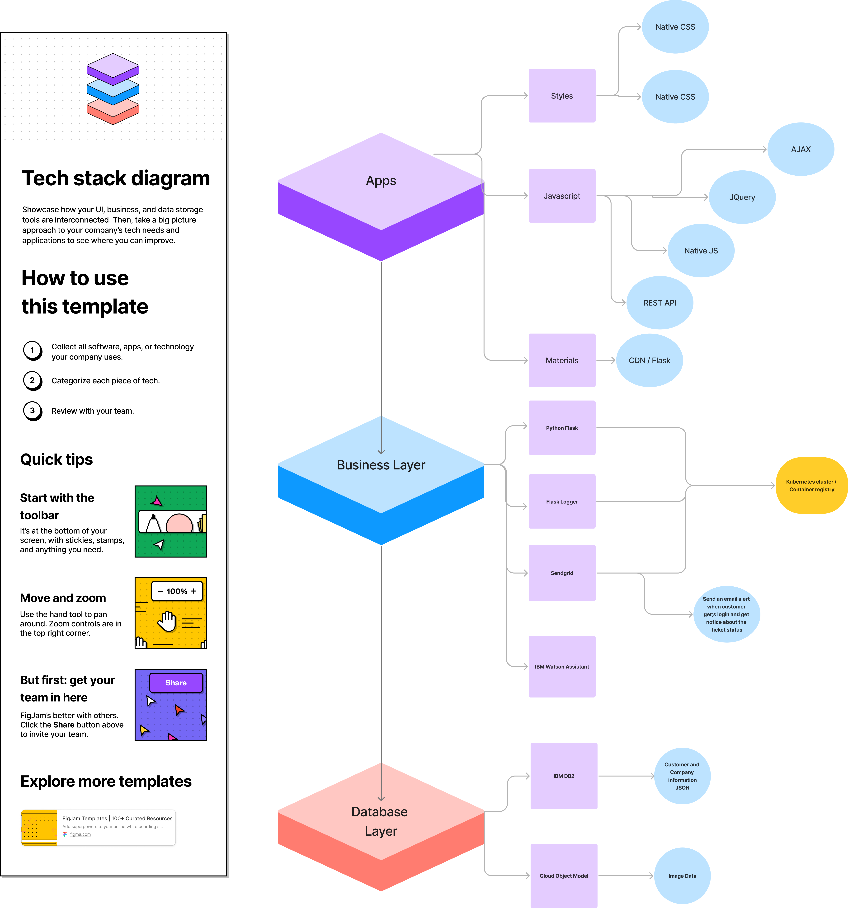

**Table-1 : Components & Technologies:**

|  |  |  |  |
| --- | --- | --- | --- |
| **S.No** | **Component** | **Description** | **Technology** |
|  | User Interface | How user interacts with application e.g.  Web UI, Chatbot etc. | HTML, CSS, JavaScript,Flask |
|  | Application Logic-1 | Logic for a process in the SMTP application | Python Flask,SENDGRID |
|  | Application Logic-2 | Logic for a process in the chat application | IBM Watson STT service ,python flask |
|  | Database | Data Type, Configurations etc. | MySQL, NoSQL, etc. |
|  | Cloud Database | Database Service on Cloud | IBM DB2, IBM Cloudant etc. |
|  | File Storage | File storage requirements | IBM Block Storage or Other Storage Service or Local Filesystem |
|  | External API-1 | Purpose of REST API used in the application | CRUD API, etc. |
|  | External API-2 | Purpose of External Google API used in the application(Oauth) | Google API, etc. |
|  | Machine Learning Model | Purpose of data & ticket analysis though Machine Learning Model | Object Recognition Model, etc. |
|  | Infrastructure (Server / Cloud) | Application Deployment on Local System / Cloud  Local Server Configuration.  Cloud Server Configuration : | Local, Cloud Foundry, Kubernetes, Docker. |

**Table-2: Application Characteristics:**

| **S.No** | **Characteristics** | **Description** | **Technology** |
| --- | --- | --- | --- |
|  | Open-Source Frameworks | Flask provides configuration and conventions, with sensible defaults for our web application. | Flask framework |
|  | Security Implementations | Password Encryption | SHA-256,OWASP. |
|  | Scalable Architecture | HTTP resource API, WebSockets. | Microservices Architecture |
|  | Availability | use of load balancers, distributed servers are available 24/7 | Sponsor IBM DB-2 |
|  | Performance | Design consideration for the performance of the application through number of requests per sec, use of Cache, use of CDN’s. | Local cache , bootstrap, fontawesome , google material |

**References:**

[**https://c4model.com/**](https://c4model.com/)

[**https://developer.ibm.com/patterns/online-order-processing-system-during-pandemic/**](https://developer.ibm.com/patterns/online-order-processing-system-during-pandemic/)

[**https://www.ibm.com/cloud/architecture**](https://www.ibm.com/cloud/architecture)

[**https://aws.amazon.com/architecture**](https://aws.amazon.com/architecture)

[**https://medium.com/the-internal-startup/how-to-draw-useful-technical-architecture-diagrams-2d20c9fda90d**](https://medium.com/the-internal-startup/how-to-draw-useful-technical-architecture-diagrams-2d20c9fda90d)